
Directory
Presented by:
Institutional Affiliation:
Date:

Table of Contents

Executive Summary 2
Systems Request Summary 2
Findings of Preliminary Investigation 4
Systems Requirements 5
Systems Design Specifications 9
Systems Implementation 10
Systems Support and Security 11
Time/Cost Estimates and Project Management 12
Expected Benefits 14
Project Lead Qualification 14
References 15

Executive Summary
This is s business management system that will allow the business owner to interact with the customers who are buying from the site. The business sells clothes on line and the e-commerce site has been of great use to the business so far. It is therefore important for the business to have a well-functioning system that will enable the customers to make orders online and get deliveries on time. The directory system is made to capture the user/customer information for the benefit of the business. The directory will be able to store user information such as their names, email, and phone number. The users will be able to save their information in the system including card number. All the orders made through the system must be recorded as well.

Systems Request Summary
The following are some of the requests that the system will request from the users who want to register. The customers/users must be able to meet the following guidelines/demands/ system requests in order to successfully use it.
Functional and Non-Functional Requirements
Functional Requirements:
- Maintain User Profile:
- The website must allow the admin of my organization (Albir Organization) to manage productive families’ profiles; By creating or deleting them.
- The website must allow the customer to create profile.
- The website must allow user to update the profile information.
- Manage Products:
- The website must enable the productive families to manage their products; by adding, deleting, editing.
- The website must allow the productive families to write information details of every products.
- Provide Search Feature:
- The website must enable the user to search about a specific product by “search Bar” feature.
- The website must notify the user if no matching of product found on the search.
- Display Products:
- The website must display all the products categories to the user.
- The website must display available hot offers to the user.
- The website must display detailed information about the products.
- Shopping Cart Facility:
- The system shall allow user to select the product to purchase.
- The website must allow user to add/delete products from the shopping cart.
- Messages Feature:
- The website must provide message option to allow communication between the customer and productive family.

Findings of Preliminary Investigation
Describe the findings of preliminary investigation, including a SWOT analysis and a description of the project’s scope, constraints, and feasibility.
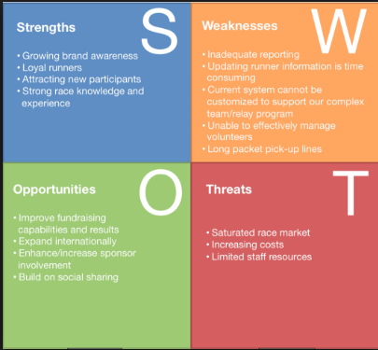
Strength
The system is build with the capacity to grow the brand awareness. The company sells garments and fashionable wears through this website. It is therefore important for the system to be available on demand and ensure that the company products are available. The system also provides guidance to the customer on how to sign up and sign in creating a strong experience for the customer.
Opportunities
On the other hand, the business must have all the details stores in the system including product stock and customer details. This directory is key for the business to expand its clientele. It is build on social sharing.
Weakness
Log product pick up lines can cause delays for the customer
The system cannot be customized to support the clientele
Threat
The market is saturated and the system faces competition.
Increased cost of maintenance of the directory is also a challenge.

Systems Requirements
Build the system’s logical model corresponding to the chosen development method. For instance, if you group has chosen OO development method, then please include the following: 1) Draw an activity diagram showing sample workflows;
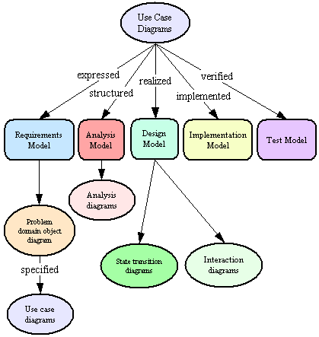
2) Identify subsystems and draw a sample use case diagram;
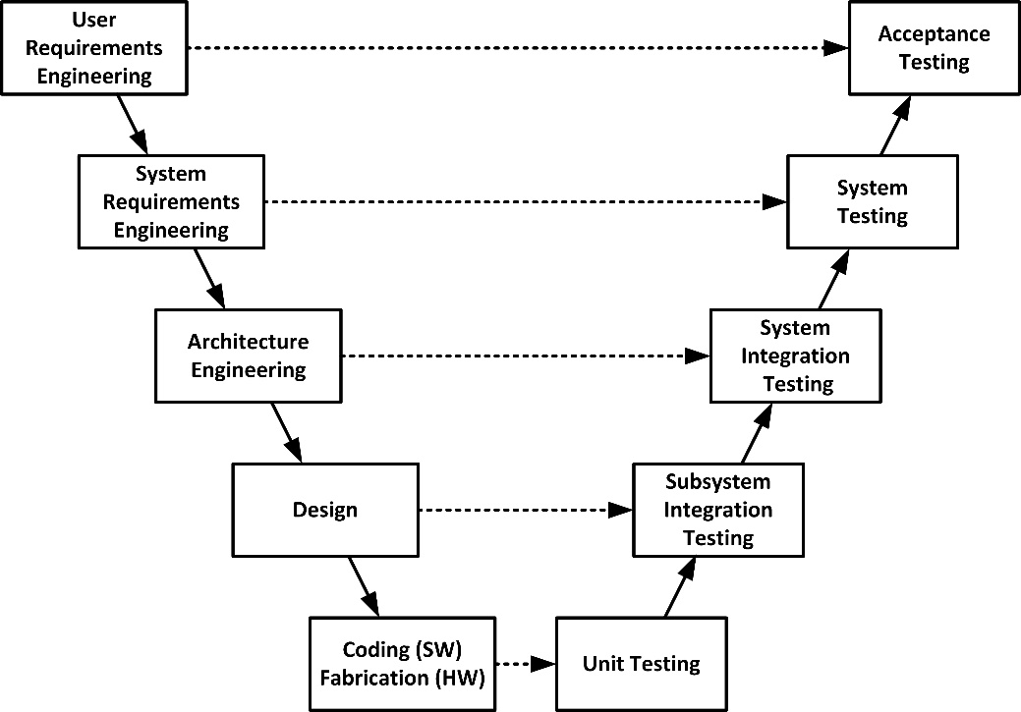
3) Draw a sample domain model class diagram for one subsystem;
User requirement subsystem
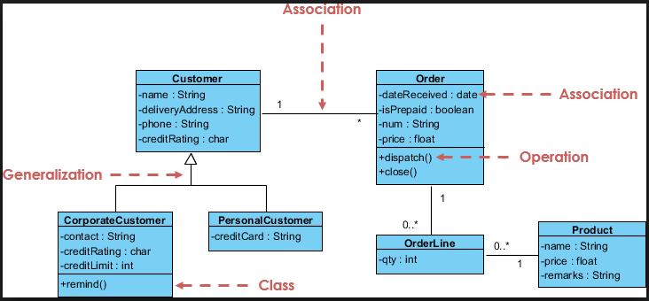
4) Develop a sample use case description in a table;
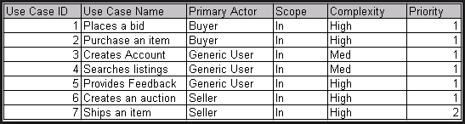
5) Draw a sample system sequence diagram; and
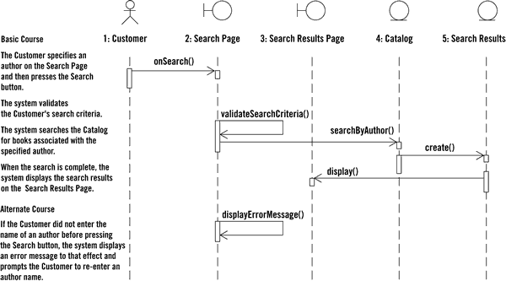

6) Draw a sample state machine. Recommend a development strategy, e.g., customize a software package (Drupal, Moodle, etc.) or develop in-house, etc.
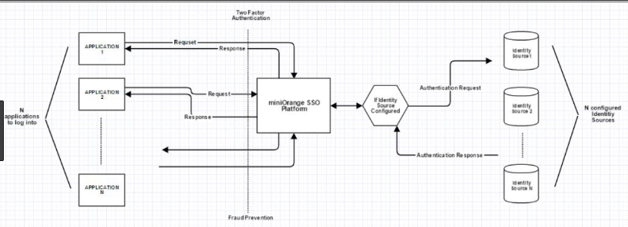

Systems Design Specifications
Create the system’s physical model: 1) Draw the system’s architecture; 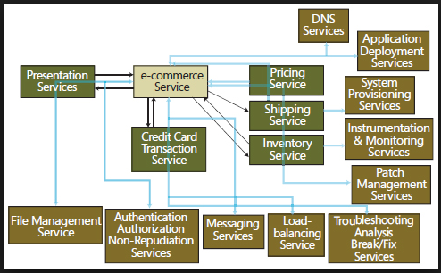
2) Provide sample design of the system, include sample user interface, outputs, inputs, files, databases, and network specifications;
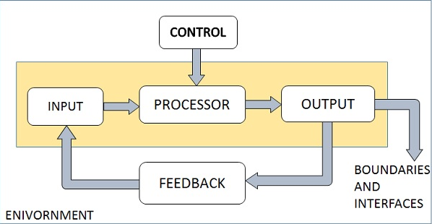
3) Draw ERDs showing all major entities and their relationships, and create a sample normalized table design that includes all necessary fields and appropriate keys.
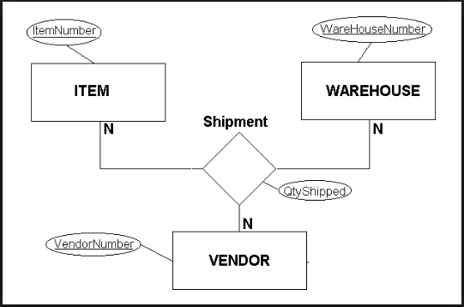
The system is designed in a manner that the user orders for an item and get the item delivered. The system is meant for the customer to order an item. However, the system compatibility to the user varies. Due to huge transactions, sometimes the system freezes which is a major challenge for the business. In terms of data storage, information is confidential and secure. The system recovery sometimes fails and may hinder transactions

Systems Implementation
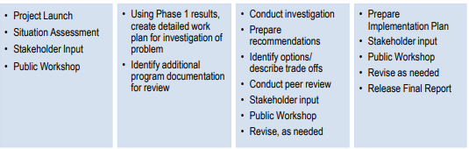
The system implementation process takes the above shape. The system is launched by the business. Sensitization program is carried out to expose the public to the system. The program is then reviewed and the necessary documentation is done to determine the progress. All the recommendations must be made after the system evaluation. For example;
- System authenticity requirements
- Stakeholders input for the system
- Necessary developments to capture and store customer’s data

Systems Support and Security
Due to the rising cases of system hacking, this system will be secure and free from malware. All the data must be protected using the right firewall. In order to address the system’s scalability, the following items must be put into place.
- The website shall be secure.
- The website shall be accessible and usable in an authorized manner by authorized users.
- The website shall protect the privacy of users’ and productive families’ personal information.
- The website shall secure the messages between the productive families and customers.
- The website shall use strong SSL [Secure Sockets Layer] authentication in all transactions.
- The website shall use HTTPS and include the padlock icon in the address bar.
- The website shall require the use of strong passwords by all users.
- Passwords shall always be echoed with special characters representing typed characters.
- The website shall never display a customer’s credit card number after retrieving from the database, it must always be displayed with just the last 4 digits.
- Integrity:
- The website shall maintain the consistency and accuracy of data.
- The website shall ensure that data cannot be changed by unauthorized people.
- Usefulness:
- The website shall meet the relevant needs of the productive families and the users.
- The website shall provide search bar.
- The website shall provide icons and toolbars.

Time/Cost Estimates and Project Management
The project is expected to cost the business a whopping $2,000 for the system launch. Further cost which might be necessary include maintenance fee which will be updated as per the consultancy services. The entire project will be maintained by the company’s IT team. The system will be timely and all orders must be delivered on time with the help of the logistics team. In terms of system management, the following team will be responsible in different responsibilities and duties.
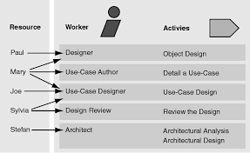
Grant chart
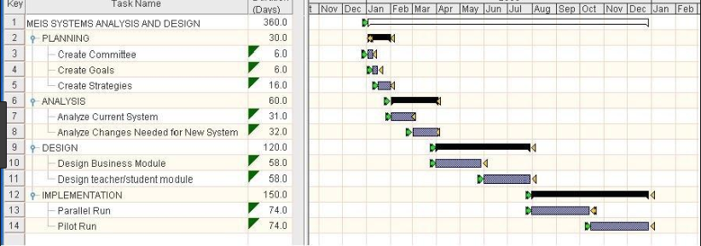

Expected Benefits
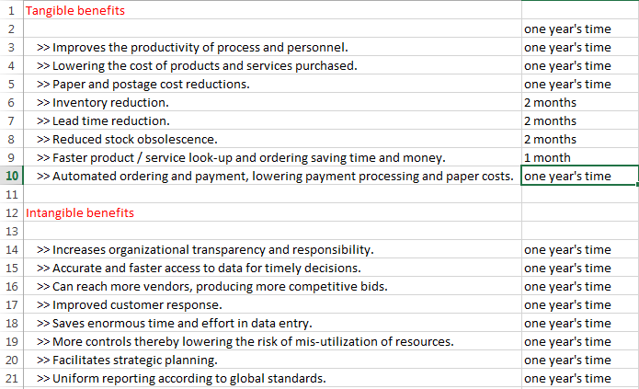

Project Lead Qualification
The project need expertise in the implementation program. It is therefore important to have skilled project team led by a project manager to ensure that the project completion is a success.
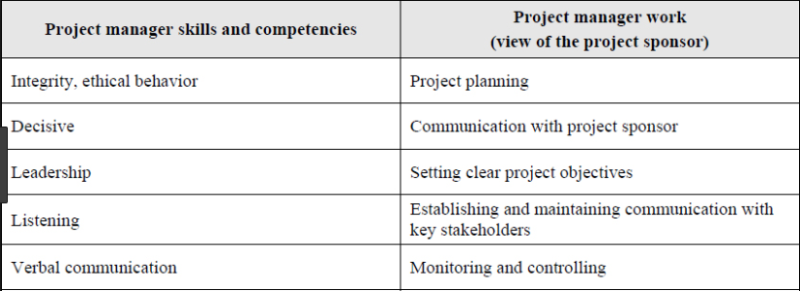

References
Astarina, E. N., & Universiti Malaya. (2011). An integrated web-based directory and e-commerce system for agriculture-based food cottage industry in Malaysia.
Bajaj, K. K., & Nag, D. (2015). E-commerce: The cutting edge of business. New Delhi: Tata McGraw-Hill Pub.
Carrington, C. (2012). Enterprise directory and security implementation guide: Designing and implementing directories in your organization. San Diego, Calif: Academic Press.
Cashin, J. (2018). E-commerce success: Building a global business architecture. Charleston, SC: Computer Technology Research.
Harmon, P., Guttman, M., & Rosen, M. (2011). Developing E-business systems & architectures: A manager's guide. San Francisco: Morgan Kaufmann Publ.
Qin, Z. (2016). Introduction to e-commerce. Berlin: Springer.
Rajput, W. E. (2018). E-Commerce systems architecture and applications. Boston, Mass: Artech House.

